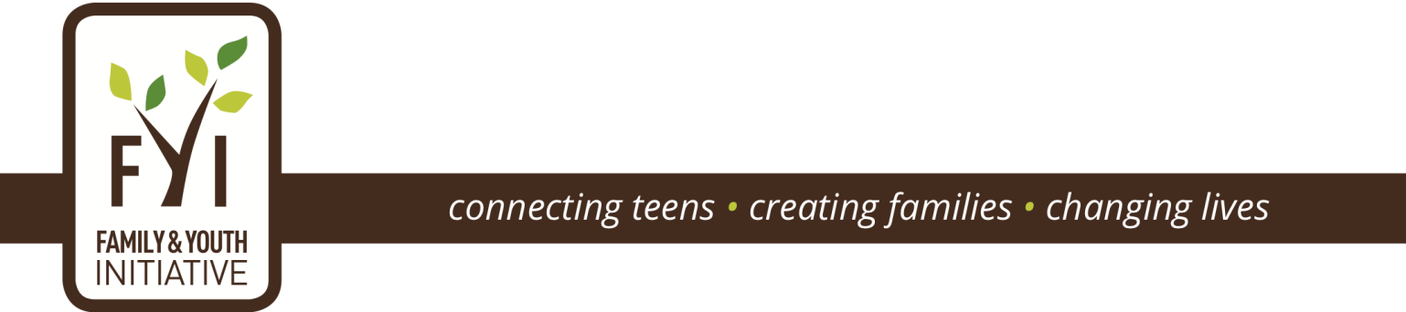

Establishing Roots Annual Fundraising Reception
October 7, 2015

Honoring Barbara Harrison,
NBC News4 Anchor and creator and host of “Wednesday’s Child”

Honorary Co-Chairs
Honorable Anthony Williams | Councilmember Charles Allen  Councilmember David Grosso  Councilmember Brianne Nadeau
Representative Eleanor Holmes Norton (DC)  Representative Karen Bass (CA)  Representative Jim McGovern (MA)  Representative Gwen Moore (WI) | Senator Roy Blunt (MO)  Senator Tammy Baldwin (WI)  Senator Chuck Grassley (IA)

SPONSORSHIP BENEFITS

Sponsoring Family & Youth Initiative’s Establishing Roots: A Fundraising Reception offers sponsors the opportunity both to provide direct support for DCFYI’s mission of finding adoptive families for teens in foster care and to express to the wider community your commitment to the importance of DCFYI and its mission.

SPONSORSHIP LEVELS AND BENEFITS

LEVEL | CONTRIBUTION | BENEFITS
Diamond Sponsor | $10,000 or more | - Recognition during program  - If sponsorship received by July 15, inclusion in event invitation  - Full page ad inside front cover or back page of print program  - Organization name and logo on thank you board at event  - Organization logo & website link on DCFYI website  - Three times weekly social media mention through end of October, including event photos  - Twenty tickets to reception
Platinum Sponsor | $5,000 - $9,999 | - Recognition during program  - If sponsorship received by July 15, inclusion in event invitation  - Full page ad in print program  - Organization name and logo on thank you board at event  - Organization logo & website link on DCFYI website  - Twice weekly social media mention through end of October, including event photos  - Fifteen tickets to reception
Gold Sponsor | $2,500 - $4,999 | - If sponsorship received by July 15, inclusion in event invitation  - Half page ad in print program  - Name on DCFYI website; if organization, will include logo & link to website  - Organization name and logo on thank you board at event  - Weekly social media mentions  - Ten tickets to reception
Silver Sponsor | $1,000 - $2,499 | - Quarter page ad in print program  - Name on DCFYI website; if organization, will include logo & link to website  - Organization name and logo on thank you board at event  - Eight social media mentions  - Six tickets to reception
Bronze Sponsor | $500 - $999 | - Sponsor name and logo in print program  - Name on DCFYI website; if organization, will include logo & link to sponsor website  - Six social media mentions  - Four tickets to reception
Friend | $250 - $499 | - Listing in print program  - Name on DCFYI website; if organization, will include logo & link to website  - Social media thank you’s  - Two tickets to reception

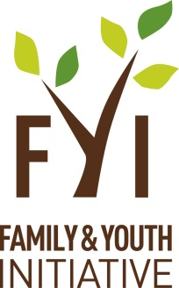
SPONSORSHIP FORM
Establishing Roots: Annual Fundraising Reception
October 7, 2015
We appreciate our sponsors; thank you!

______________________________________________________
Sponsor’s Name

_______________________________________________________________
Address

________________________________________________
City State Zip

____________________________________________ _____________________________
Name of contact person Phone

Email: ___________________________________ Website: __________________________

Sponsorship amount: $__________

Payment method: (check one) Check □ Credit Card □
Checks can be made payable to: Family & Youth Initiative
Credit Card: MasterCard □ Visa □ Amex □ Discover □

Card number: __________________________________________ Exp. Date: ___________ Security code: _________

Authorizing signature: ________________________________________________________ Date: _____________

PLEASE COMPLETE THIS FORM AND RETURN WITH YOUR PAYMENT TO:
Family & Youth Initiative
515 M Street, SE
Suite 217
Washington, DC 20003

DCFYI Tax ID#: 38-3828204

DEADLINE: September 25, 2015 to be included in event program

